Books Donation Project
By Japan Tobacco and Allies Workers’ Union

Introduction

In June 2007, Japan Tobacco and Allies Workers’ Union (JT) visited “Ban Phason Chokchai School” on Minsai study tour. Recently, JT received a letter from the school saying that the school needs more books because their library have not enough books, and most books are illegible or out-of-date textbooks in poor condition. So, JT determined to contribute an amount of 300,000 Yen for new books to the school. In July 2010, to celebrate 60th anniversary of their establishment, JT makes a presentation of books donation as part of the celebration. In addition to this special donation for Phason Chokchai School, JT also provide scholarships for 17 students with approximately 90,000 Yen.

With the grateful contribution from JT, the school has good library and sufficient books for the students that create appropriate learning atmosphere. Moreover, received new educational books in the library, it becomes a center for the students where they can spend free time for studying. On top of that, the students are also able to access the up to date information that is useful for their study and lives.

Project Objectives:

1. To support budget for the school for educational books

2. To solve insufficient book problem and provide better learning resources for the school

3. To enhance the school library and become an appropriate learning center for students

4. To generate love-reading behavior and encourage self-studying among the students

Project Duration

Month | Plan
June 2010 | - Project Proposal and Budget submitted  - Send book information to EDF Japan
July 2010 | - EDF officially announces the result to school and send copy to Office of Educational Service Area Office, Ministry of Education  - Order and purchase new books  - Send book presentation photos to EDF Japan
August –October 2010 | 1st Love-reading Activity  - Drawing contest  - Essay contest  - Quizzes competition  Etc,

School information: Ban Phason Chokchai School

Address: Moo 7, Ban Phason Chokchai Village, Tambon Comphi, Amphoe Suvannakhuha, Nongbua Lamphu province, Thailand 39270
Tel. +66 42-319-054, +66 4 2-952-028
Mobile. +66 8 937-5228

School Director: Mr.Vichit Littaprom

Area of Educational Service provision:
Ban Phason village
Ban Chokchai village Moo 8
Ban Chokchai village Moo 12
Ban Petchthong village Moo 14

Class service provision: Kindergarten year 1 – Junior high School Year 3

Number of students: 350

Number of teachers: 18 teachers

School overview: The school is located 100 km. far away from city. It takes around 1.30 hour. The people in a local community earn their living by agriculture. Most of them are lack of education and poor. However, as the school is in remote area, it urgently needs support for facilities renovation and it also faces difficulties to provide lunch for students. Right now, the school wants to implement agricultural project but due to the budget shortage, the project has been postponed till the next semester.

Book Donation

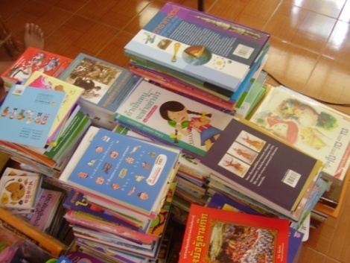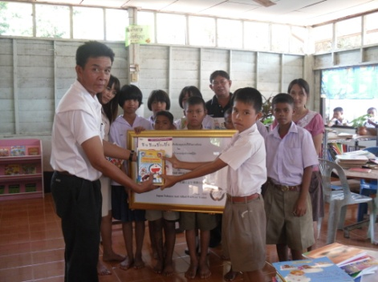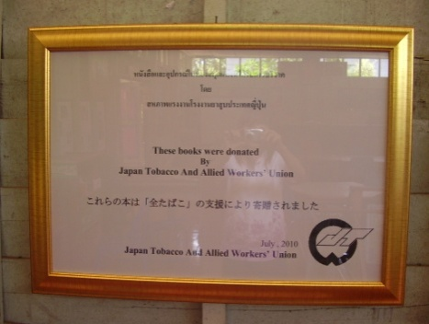The books were ordered and donated to school on 1st of July. 868 books for Junior high school students were offered to the schools. After the books were delivered, donation sign and rubber stamp were sent to the school the week later. The school was very happy with the books and the students seemed to be very excited with new various educational donation books.

Number of Books by genre

1. Reference books i.e. Dictionary Thai-English & English-Thai, Encyclopedia 150 pieces
2. Documentary books i.e. health, biology 150 pieces
3. Fiction i.e. short story, epic, folk tales, poems, general knowledge 200 pieces
4. Free reading-outside reading, 118 books
6. Text book i.e. mathematics, art, social sciences, biology, Thai and English text books 150 pieces.
7. Magazine &Journal i.e. health magazine, nutrition & health, education 100 pieces.

Total of books are 868 pieces and all of them are for Junior High School Students.

Future plan

The school will start love-reading activities in order to gain full benefit of the donation books. The activities such as drawing contest, essay, quizzes game competition, one activity will be conducted every month. Thus the actives will be a tool to encourage students to read and use the library more frequency. Moreover, the school will also plan to invest in facilities and books for its library to encourage the students to spend their free time in the library. Also, the book will also be available for students who would like to borrow for home-reading. However, to make a sustainable improvement and achieve the objectives of becoming the learning center, the school needs to improve an old library and purchasing more books. As well, they can also increase the number of activities that promote love-reading activity. Therefore, continual support is necessary for Phason Chokchai School.

Commendatory

Teacher
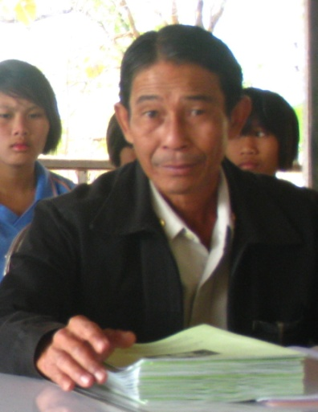
“We are glad for Japan Tobacco and Allies Workers’ Union generous contribution to our school and we offer our sincere and heartfelt gratitude. Our school and students are lucky for this grateful support. As our school is located in remote area and we are suffering from budget shortage, it is difficult for us to provide modern books for our students. I am confident that the contribution from Japanese Tobacco Workers’ Union will become a significant remark. It gives an opportunity for our poor kids to have a tool to improve themselves. I am the one who believe that it is worth to invest in education or everything that can support education. Once, the students gain knowledge, they can develop their skills and it can also be applied for daily work. We promise that we will use fully benefit of these books and maintain the books in our school as long as possible.” said Mr.Vichit Littaprom, Director,
Phason Chokchai School
Mr.Vichit Littaprom

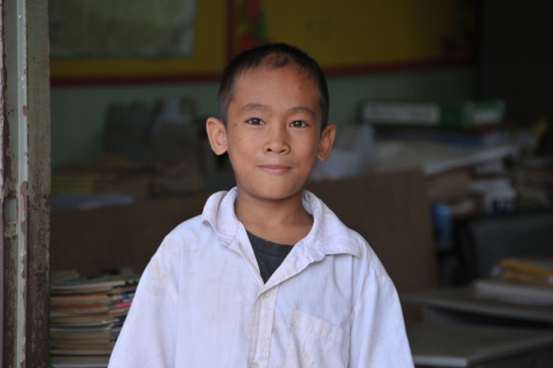
“Our library is beautiful, nice and more alive than before because of the kind support from
Japan Tobacco Workers’ Union in cooperation with EDF. We would like to express our sincere thank to them for this opportunity on education,” said Mr.Surachai Jaidee, Junior High School year 1, Ban Phason Chokchai School.

Mr.Surachai Jaidee

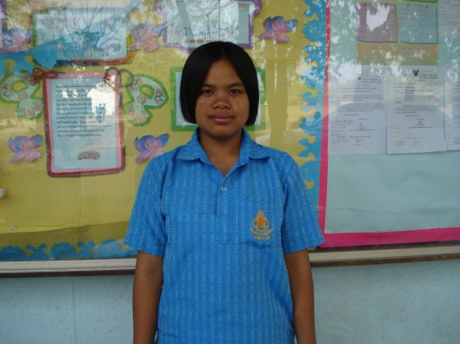“Our library is different. It looks new and many books are on the shelves my friends and I feel very excited once I see those new books. They are all interesting. We cannot wait for long to read them. Today, we come in to the library more often. I love the books and I will take care of them. I will help my teachers to maintain the books and library. Our library is revived right now. It will not happen if there is no support from Japanese Tobacco Workers’ Union. Thank you for your contribution” said Ms.Chutima Nakum, Junior High School year 1, Ban Phason Cholchai School.
Ms.Chutima Nakum

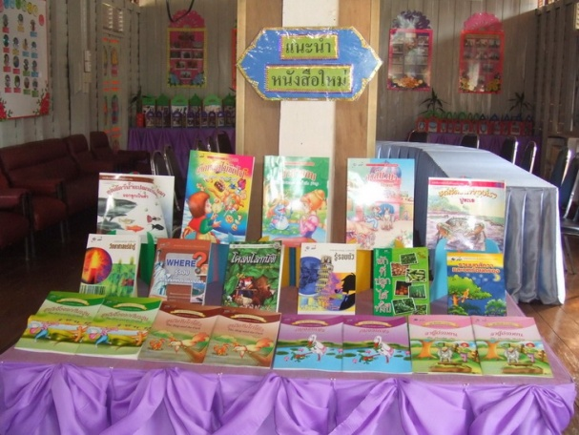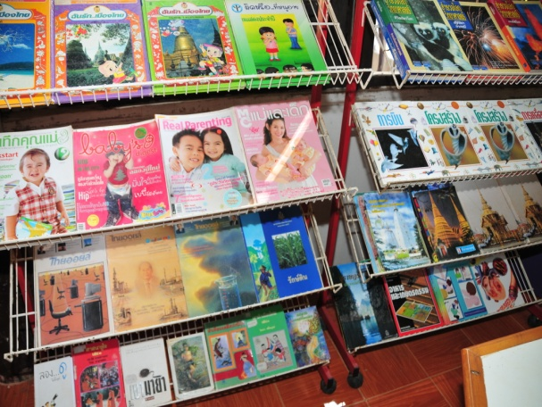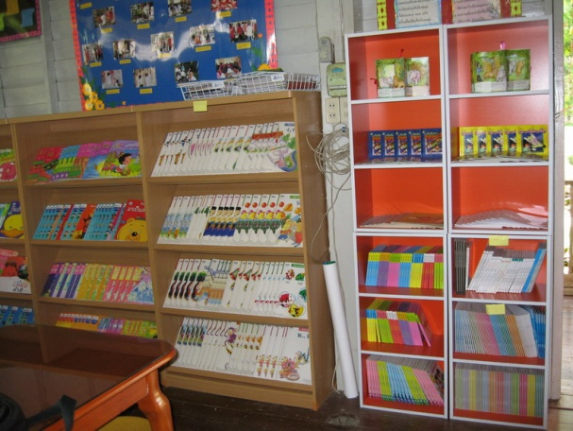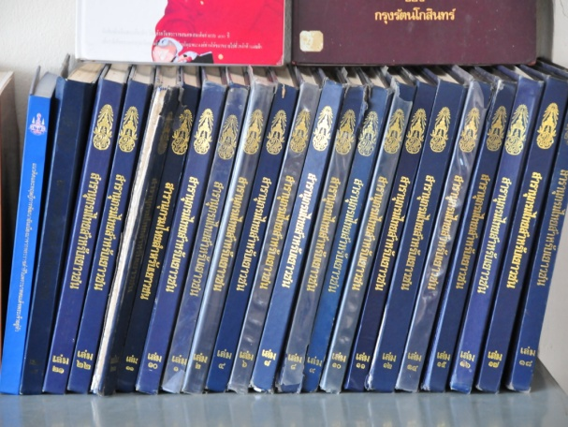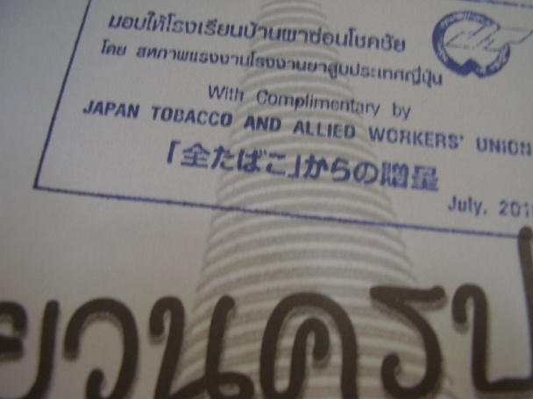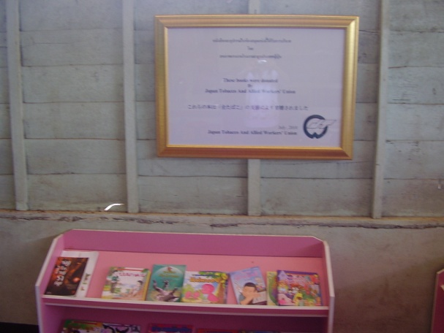 Gallery

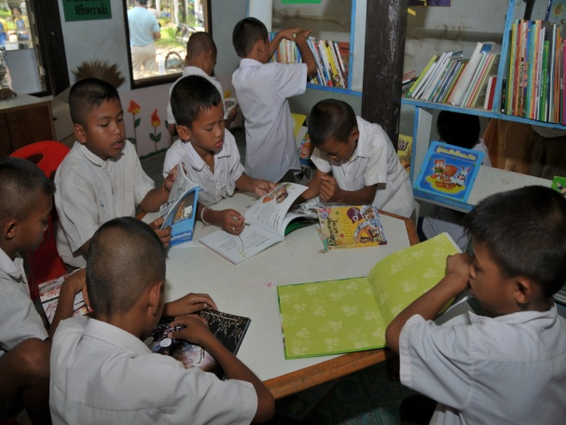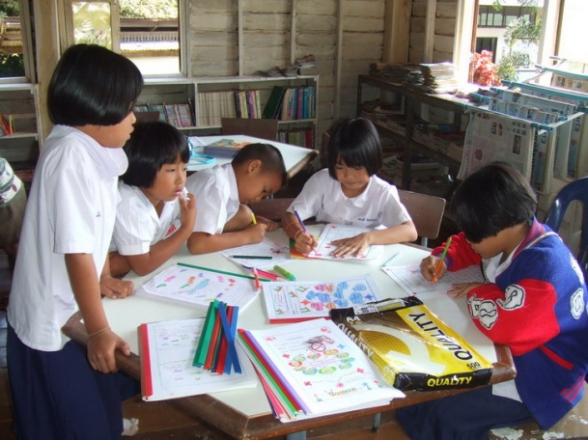

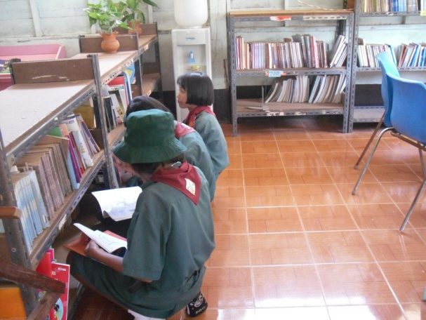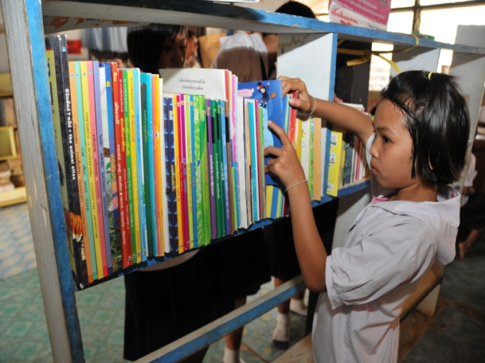

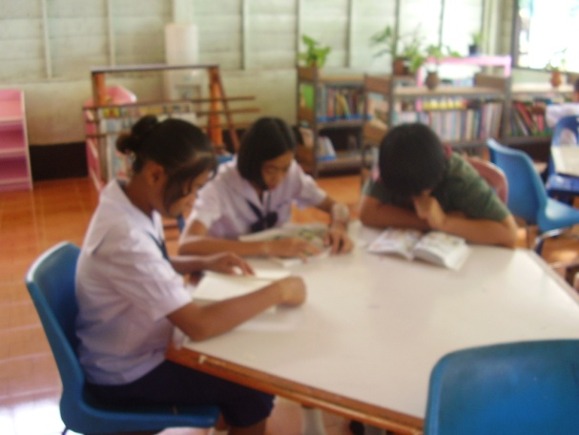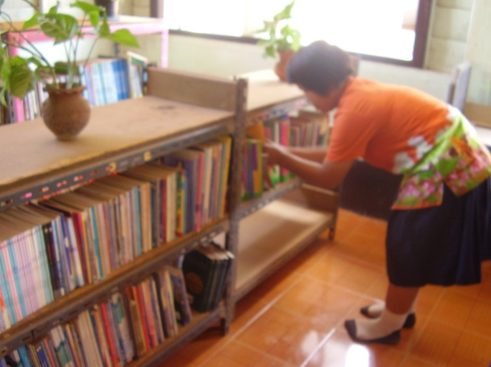

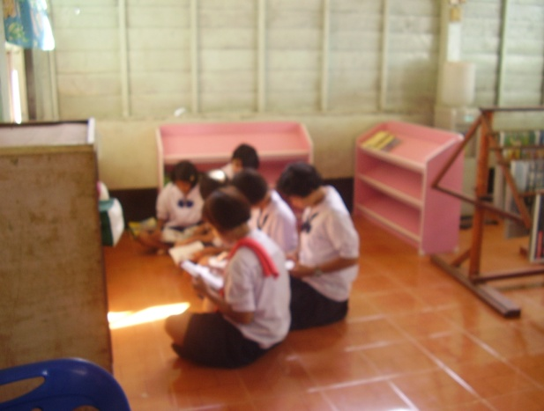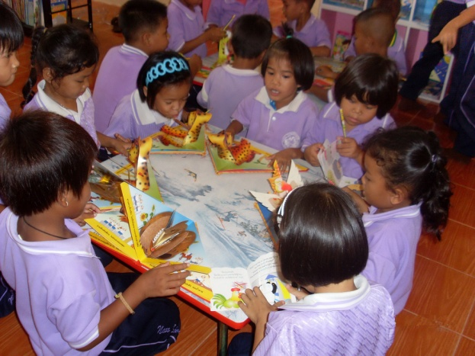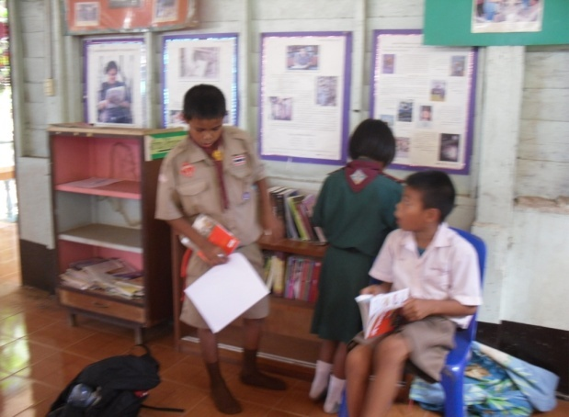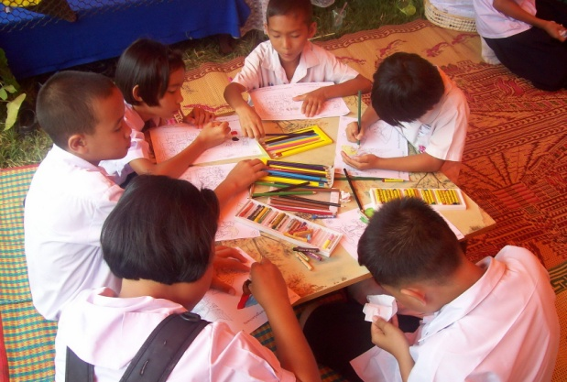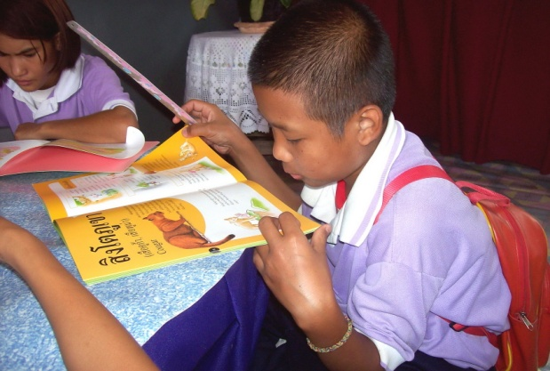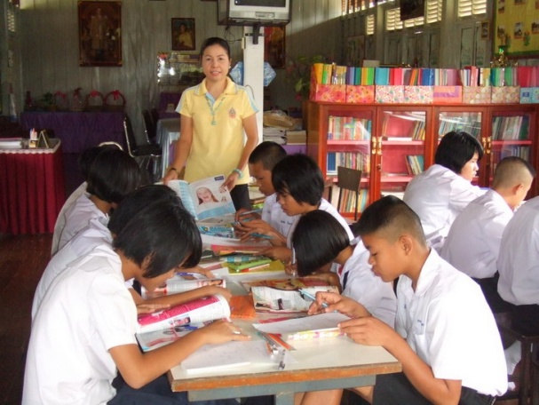

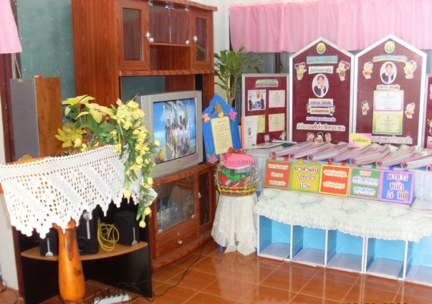

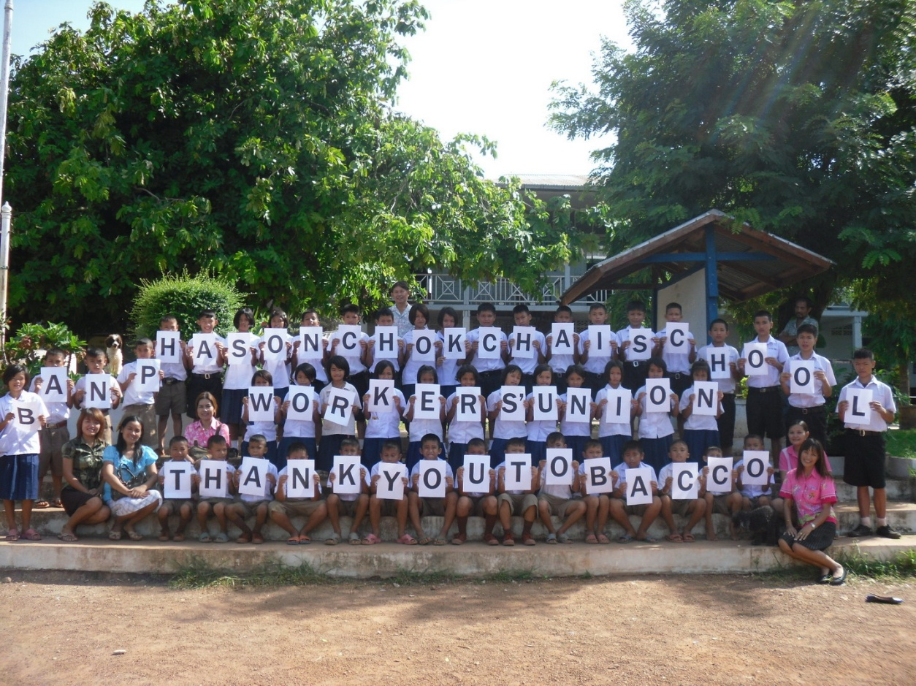

Thank you Japan Tobacco and Allies Workers’Union
for
Your Grateful Contribution

